**Guided Capstone Project Report**

Big Mountain Resort current price is $81.00

Big Mountain Resort modelled price is $95.87, which leads to a $14.87 increase in ticket price.

**Assumptions:** Other resorts in the data set have set their ticket price based on how much people value certain facilities.

**More data:**

1. Number of visitors for each resort every year.
2. Operating costs for each resort every year.

These additional data could have improved the performance of the pricing model.

**Important features identified in modeling:**

1. fastQuads - The number of fast four person chairs.
2. Runs - Count of the number of runs on the resort.
3. Snow Making _ac - Total area covered by snow making machines in acres.
4. Vertical_drop - Vertical change in elevation from from the summit to the base in feet.
5. SkiableTerrain_ac - Total skiable area in square acres.
6. total_chairs - Sum of all the chairlifts at the resort.

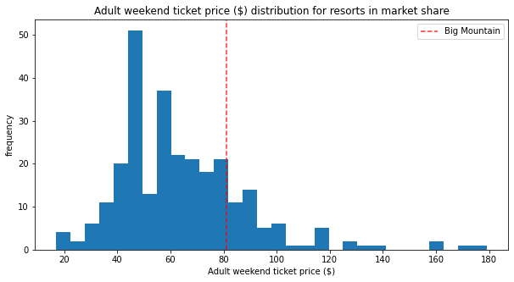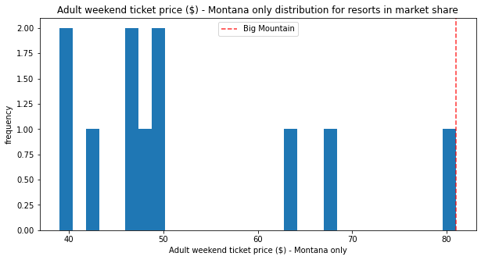

Left figure shows where Big Mountain’s current ticket price stands when compared with other competitive resorts. And the right figure shows where its’ current price is when compared with other resorts only in Montana.

Following scenarios were tested assuming Blue Mountain has an average of 350000 visitors every year and each buys 5 tickets (for 5 days).

**Scenario 1:**

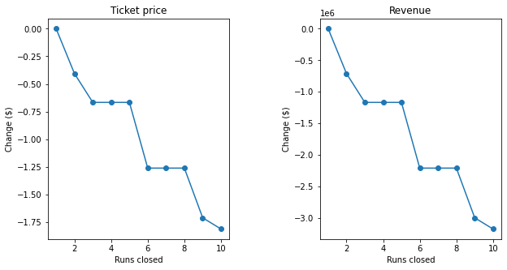

According to the fitted model, closing one run makes no difference in ticket price and revenue. However, closing 2 and 3 runs successively may reduce the support for ticket price and hence the revenue. Closing 4th and 5th runs would not make further loss in ticket price.

**Scenario 2:**

If Big Mountain decides to add a run, increase the vertical drop by 150 feet and install an additional chair lift, it will increase the support for ticket price by $8.61, resulting in a revenue increase of $15065471 for the season.

**Scenario 3:**

If Big Mountain decides to add a run, increase the vertical drop by 150 feet, install an additional chairlift, and add 2 acres of snow making, it will increase the support for ticket price by $9.90, resulting in a revenue increase of $17322717 for the season.

**Scenario 4:**

Increasing the longest run by 0.2 miles and adding 4 acres of snow making capability will make no difference.

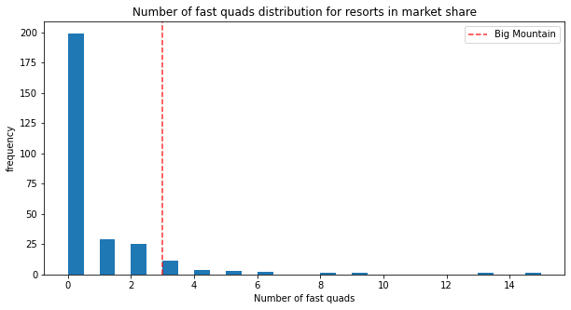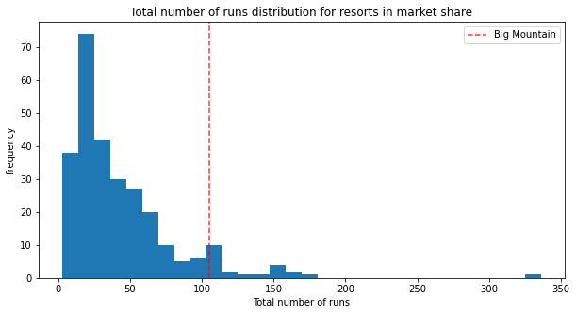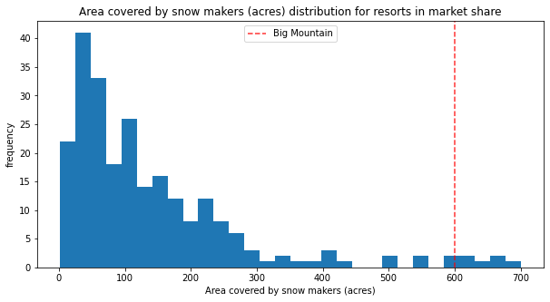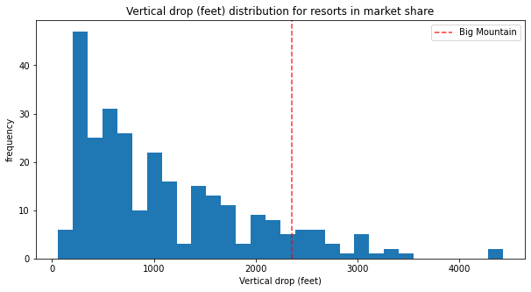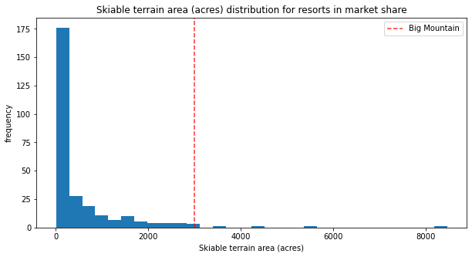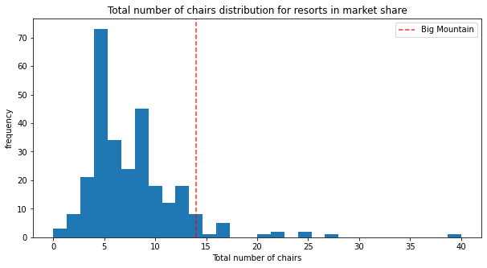

Comparing the 6 most important features of Big Mountain with other competitive resorts, it could be observed that Big Mountain stands well with many of them. However, it seems worth focusing on the vertical drop.